

SCHOOL OF COMPUTING AND INFORMATICS
DEPARTEMENT OF INFORMATION TECHNOLOGY

TITLE: Smart Food Rescue Mobile

STUDENT: MBUGUA LUCY WANGUI
REG NO: BIT/2024/44576

FIGURE 1:INSTALLATION PROCESS
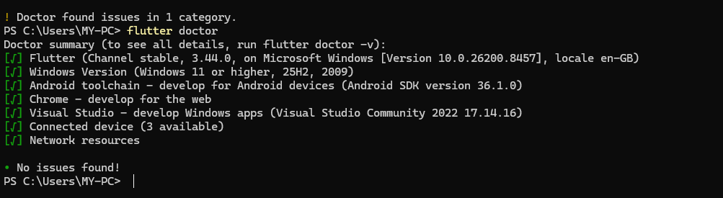

FIG 2: TERMINAL: set the folder structure
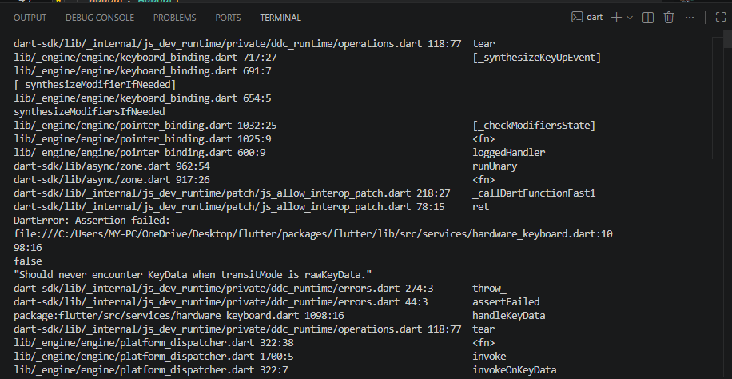

FIG 3: CODES
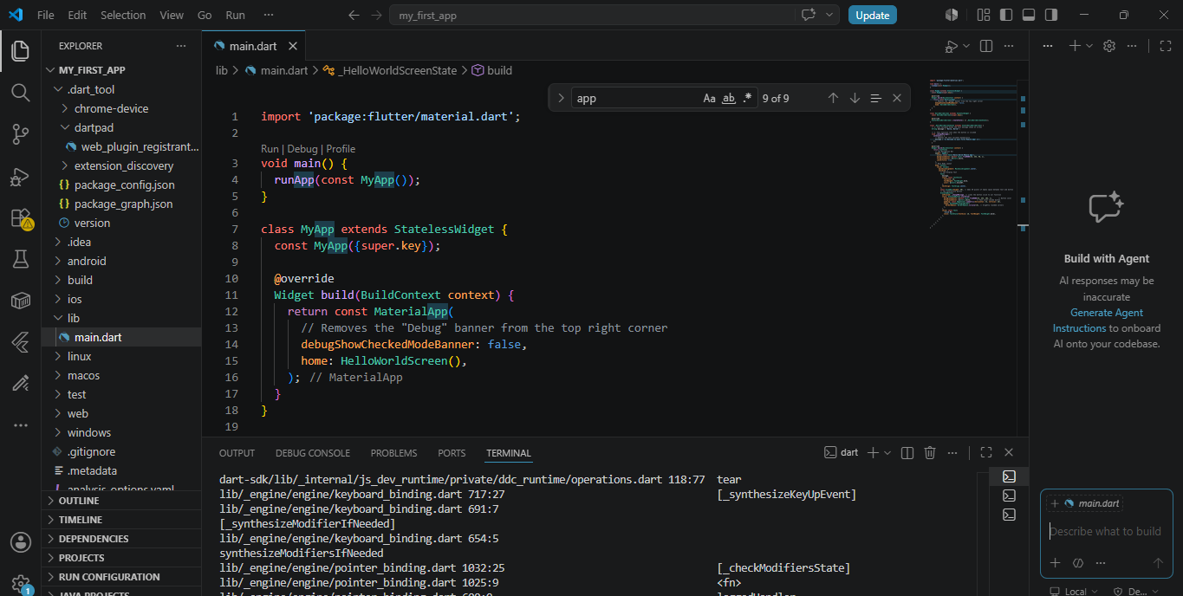

FIG 4:FIRST_APP: display
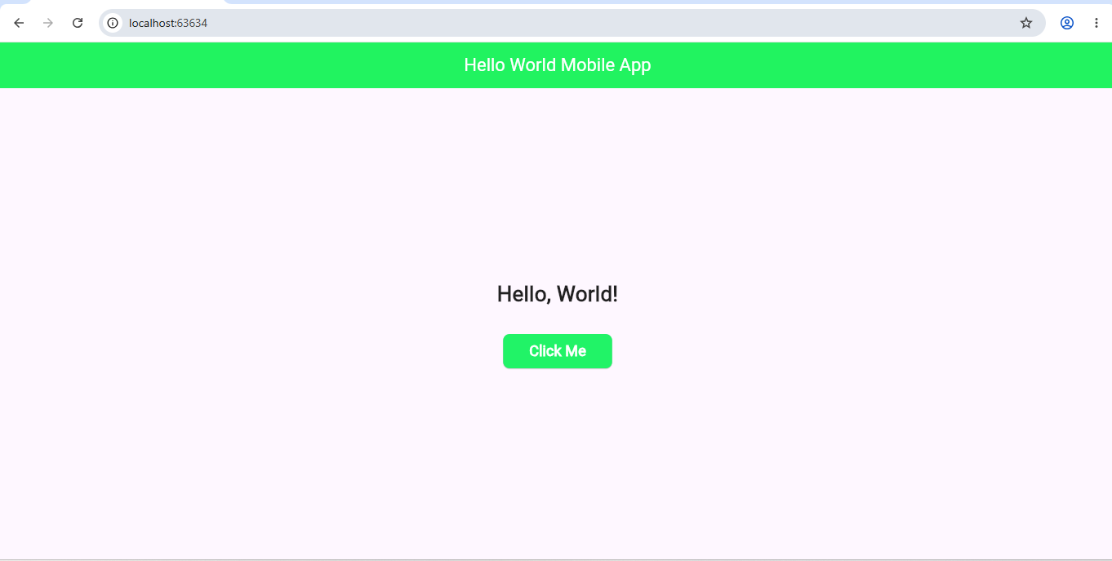

FIG 5:output after clicking
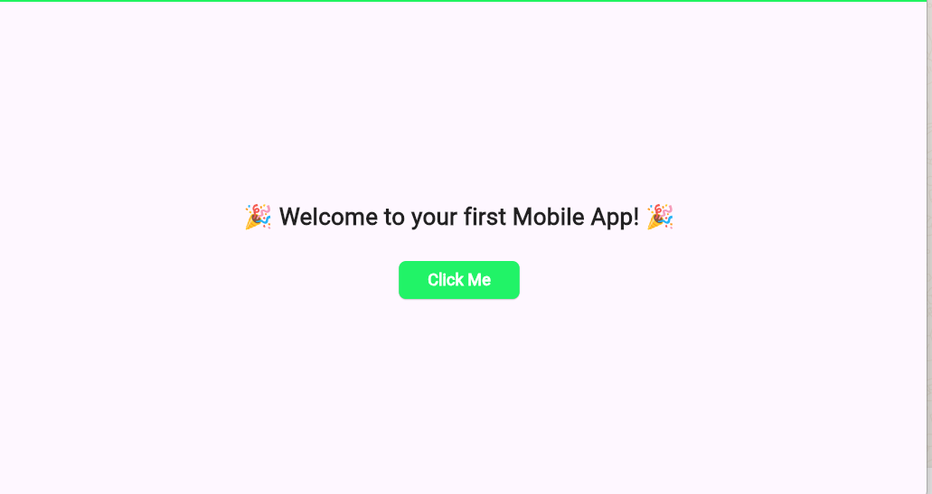

WEEK 2 -3: DEVELOPMENT OF THE MOBILE APP

Smart Food Rescue Mobile
Home screen
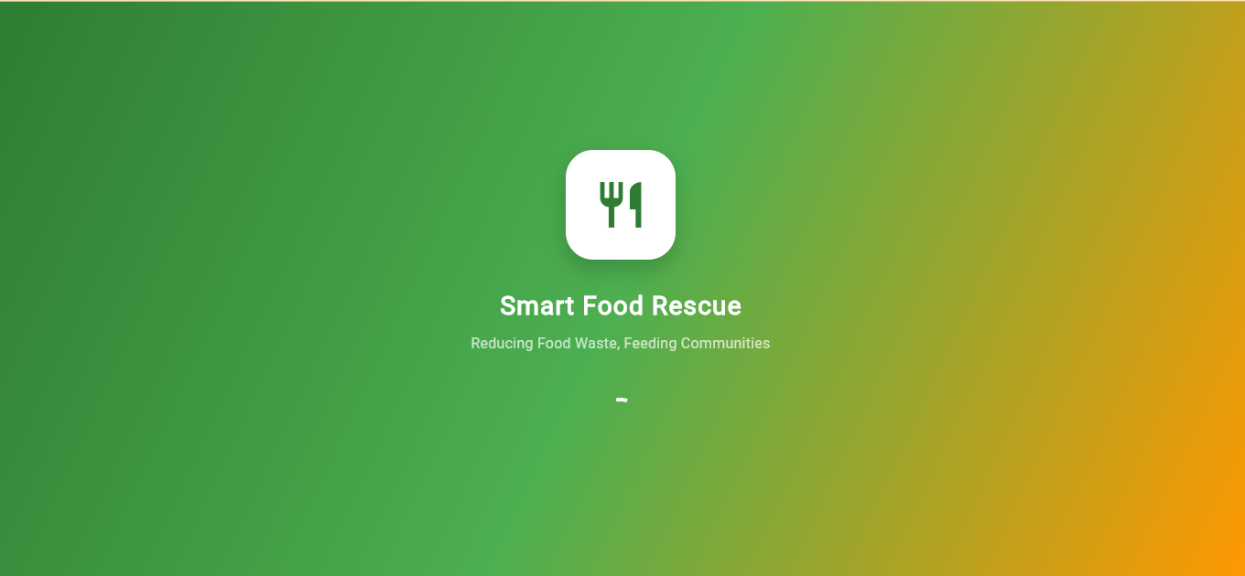

Registration Screen
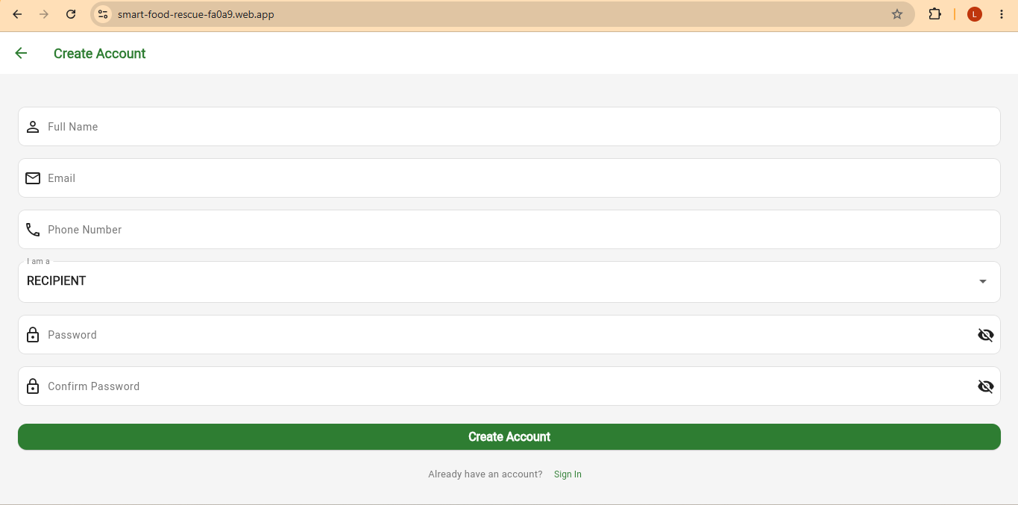

LOGIN PAGE
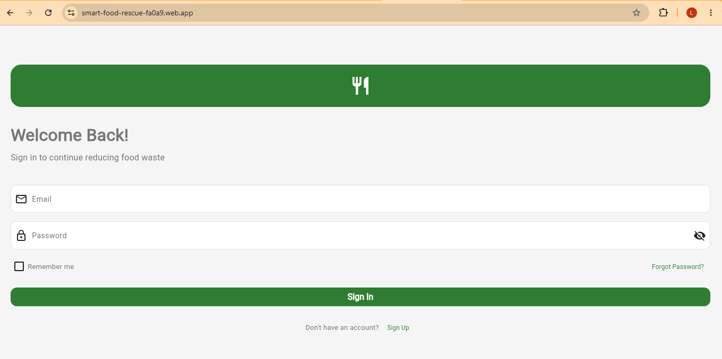

FIREBASE USERS
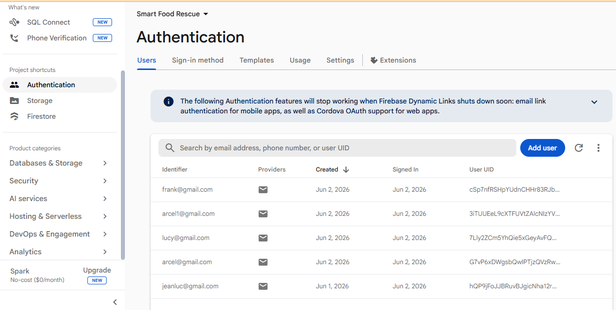

ADMINISTRATOR DASHBOARD
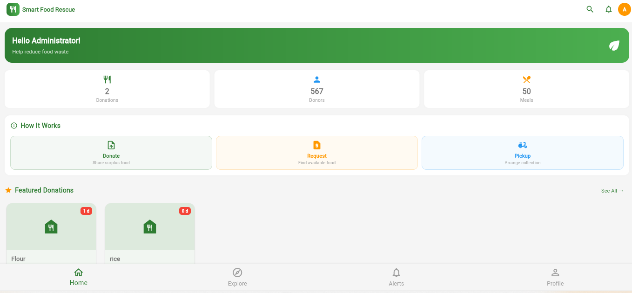

DONOR DASHBOARD
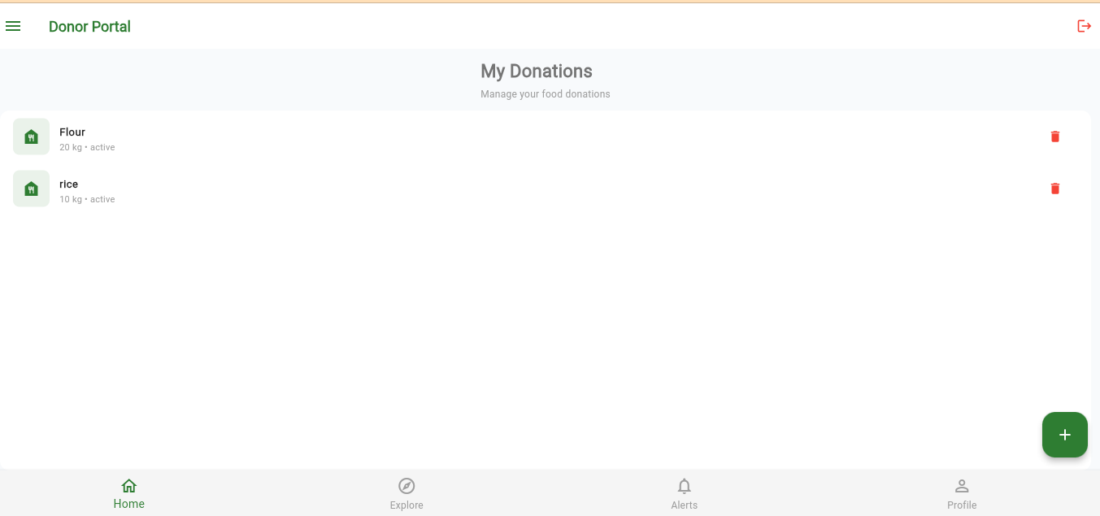

RECIPIENT PORTAL
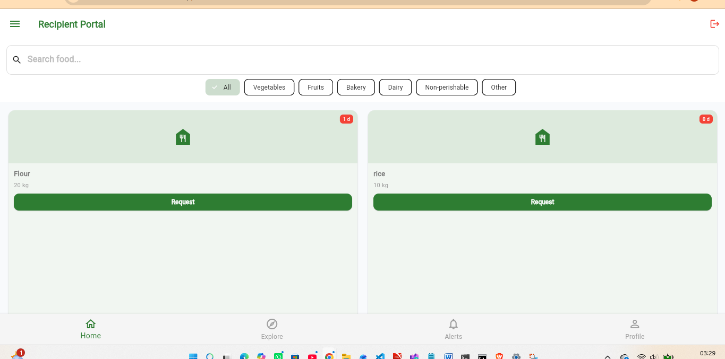

WEEK 4: DATA MANAGEMENT

4.1 Introduction
Data management is an important component of the Smart Food Rescue Mobile Application. It enables the application to collect, store, retrieve, update, and delete information related to food donations and users. The application utilizes Firebase Firestore as its primary database for managing data in real time.

4.2 Database Design
The application stores information in Firebase Firestore using collections and documents.

Users Collection
The Users collection stores information about registered users.
Field Name | Data Type | Description
userId | String | Unique user identifier
fullName | String | User's full name
email | String | User email address
role | String | Administrator, Donor, or Recipient

Donations Collection
The Donations collection stores food donation records.
Field Name | Data Type | Description
donationId | String | Unique donation identifier
foodName | String | Name of food item
quantity | String | Quantity available
location | String | Donation location
expiryDate | String | Food expiry date
donorId | String | Donor identifier
status | String | Available, Reserved, or Collected

FIREBASE DATABASE
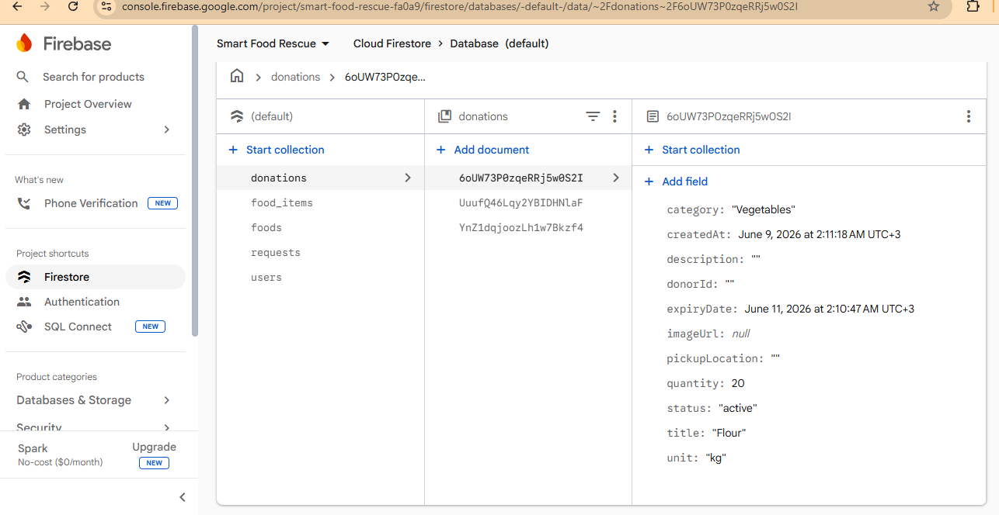

Create Donation
Donors can add new food donations by entering food details through the Add Donation form. The information is validated and saved to Firebase Firestore.
Screenshot: ADD DONATION
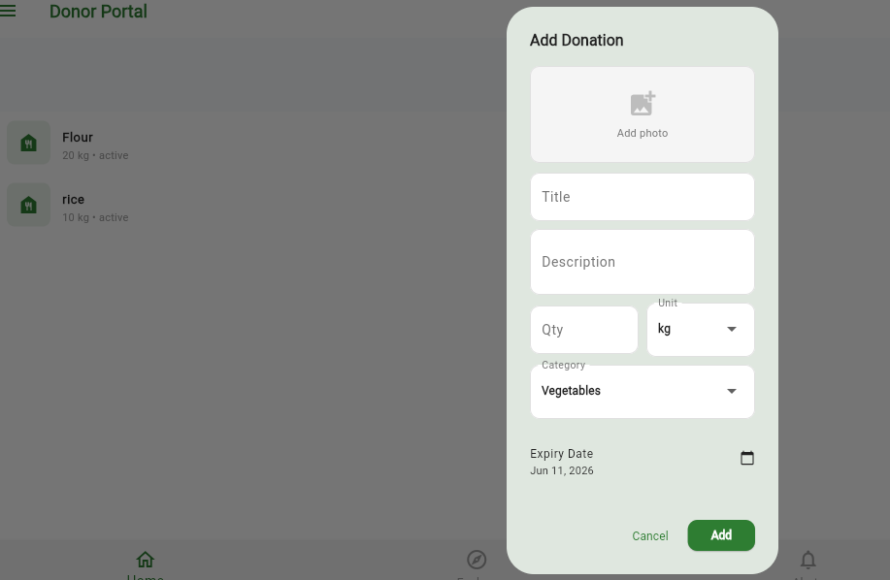
Read Donation Records
The system retrieves donation records from Firebase Firestore and displays them in a list view. Users can view available food donations and their details.
Screenshot: 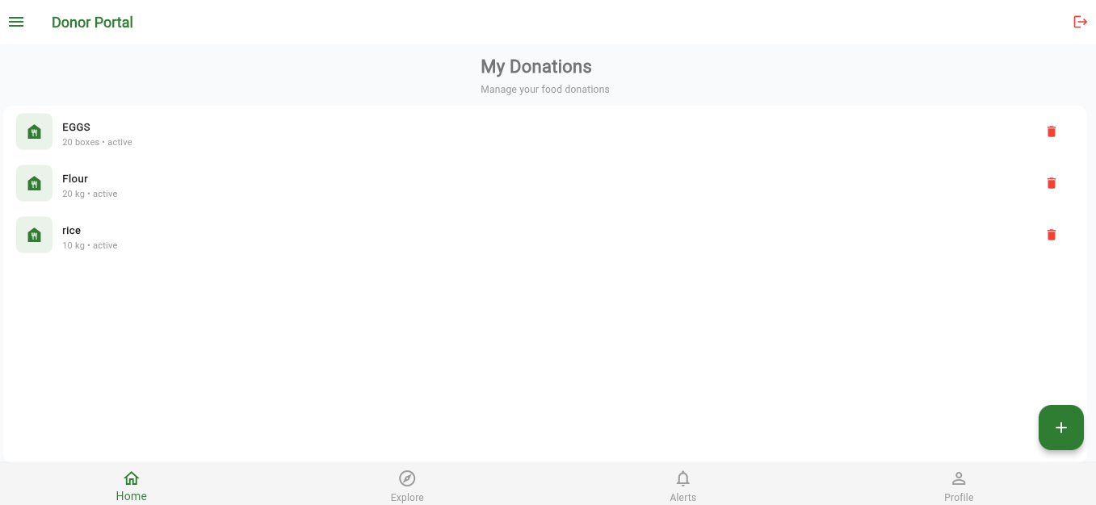
Delete Donation Records
Administrators can remove expired or invalid donation records from the system database.
DELETE DONATION
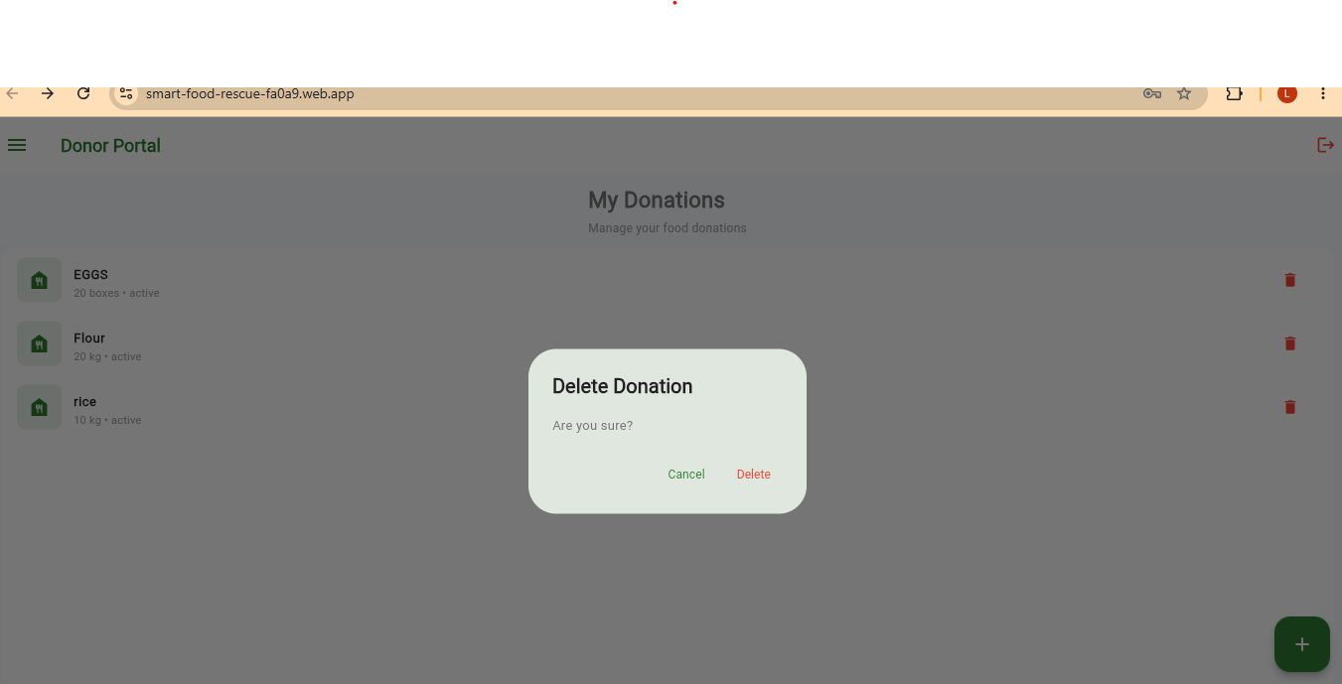
4.4 Search Functionality
The application provides a search feature that allows users to locate donations using keywords such as food name or location. Search results are retrieved dynamically from Firebase Firestore.
SEARCH DONATION
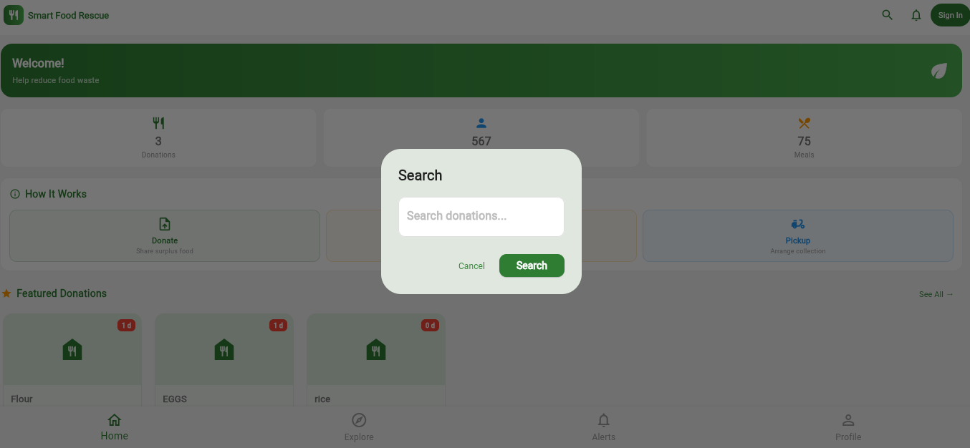
4.5 Benefits of Data Management in the Application
The implementation of data management provides several benefits:
- Persistent storage of food donation records.
- Fast retrieval of donation information.
- Efficient management of donor and recipient records.
- Improved user experience through organized data access.
- Real-time synchronization of data using Firebase.

WEEK 5: NETWORKING

5.1 Introduction
Networking enables mobile applications to communicate with remote servers and cloud databases through the internet. In the Smart Food Rescue Mobile Application, networking is used to facilitate communication between the mobile application and Firebase services. This allows users to register accounts, authenticate their identities, store donation information, retrieve records, and update data in real time.

5.2 Client-Server Architecture
The Smart Food Rescue Mobile Application follows a client-server architecture model.
Components:
- Client: Mobile Application developed using Flutter.
- Server: Firebase Authentication and Firebase Firestore.
- Network: Internet connection used for communication.
Data Flow:
- The user performs an action in the mobile application.
- The application sends a request to Firebase.
- Firebase processes the request.
- Firebase returns a response.
- The application displays the results to the user.

5.3 Application Programming Interface (API)
The application uses Firebase APIs to enable communication between the mobile application and cloud services.
The APIs perform the following functions:
- User Registration
- User Login
- Data Storage
- Data Retrieval
- Data Deletion
- User Authentication
The API integration enables real-time synchronization of donation records between users and the database.

5.4 JSON Data Exchange
Data exchanged between the mobile application and Firebase is transmitted using JSON (JavaScript Object Notation).
Example JSON Donation Record:
{
"foodName": "Rice",
"quantity": "20 Kg",
"location": "Thika",
"expiryDate": "2026-06-15",
"status": "Available"
}
JSON provides a lightweight and structured format for transmitting data between the application and Firebase services.

5.5 Data Retrieval
The application retrieves donation records stored in Firebase Firestore and displays them to users.
Functions performed include:
- Viewing available donations
- Searching donations
- Loading user information
- Updating dashboard statistics
The retrieved records are displayed dynamically on the application screens.

Screenshot: 

5.6 Asynchronous Processing
The Smart Food Rescue Mobile Application performs network operations asynchronously.
Benefits include:
- Faster application performance
- Improved user experience
- Prevention of application freezing
- Background data loading
Users can continue interacting with the application while data is being retrieved from Firebase.

5.7 API Integration
The application integrates Firebase APIs to support:
- Authentication Services
- Firestore Database Services
- Real-Time Data Synchronization
Through API integration, donors can submit donations and recipients can instantly view available food records.

API INTERGRATION SCREENSHOT
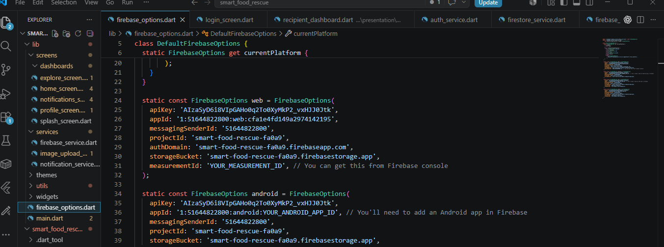
API FIREBASE SCREENSHOT
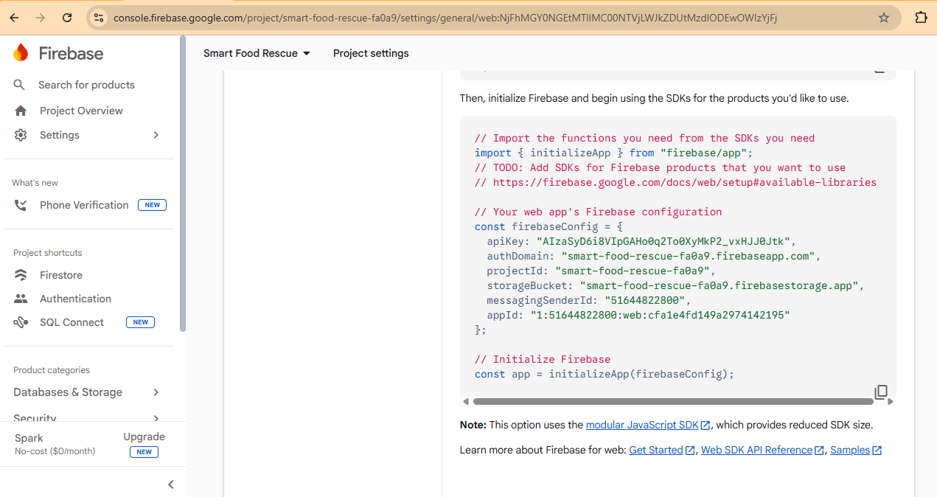
5.8 Error Handling
The application includes mechanisms for handling network and system errors.
Implemented error handling features include:
- Invalid login credentials
- Missing required fields
- Network connection failures
- Database access errors
- Authentication failures
Appropriate error messages are displayed to guide users whenever an error occur

ERROR HANDLING SCREENSHOT
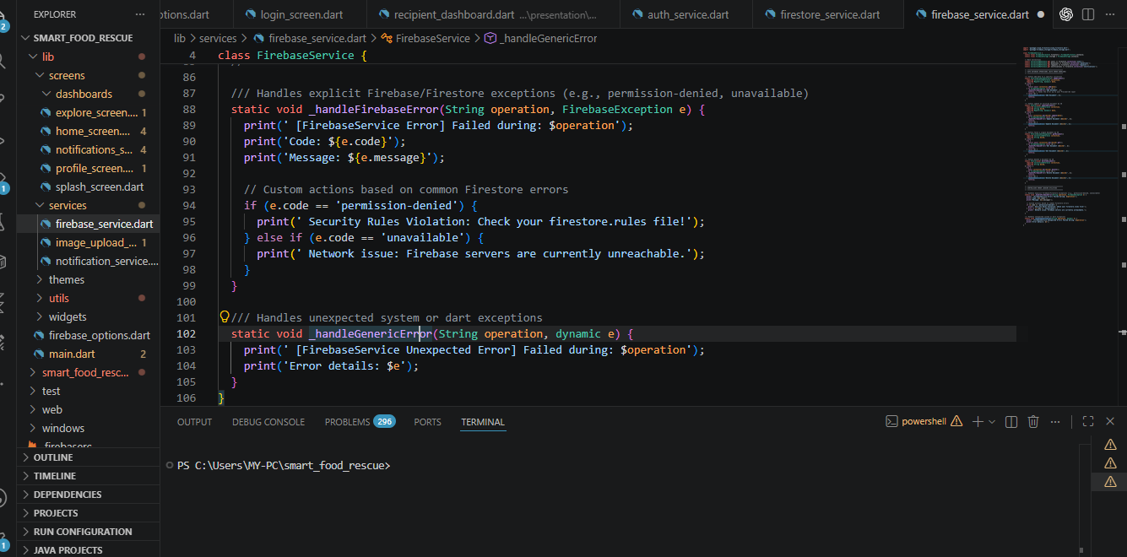
Assignment
Develop a Mobile API Consumer Application that connects to a public REST API and displays records.
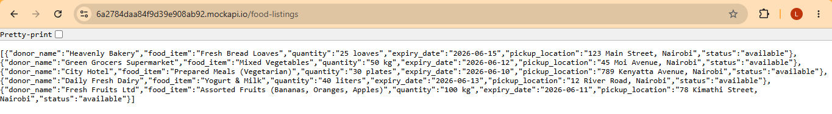Donation Document Details
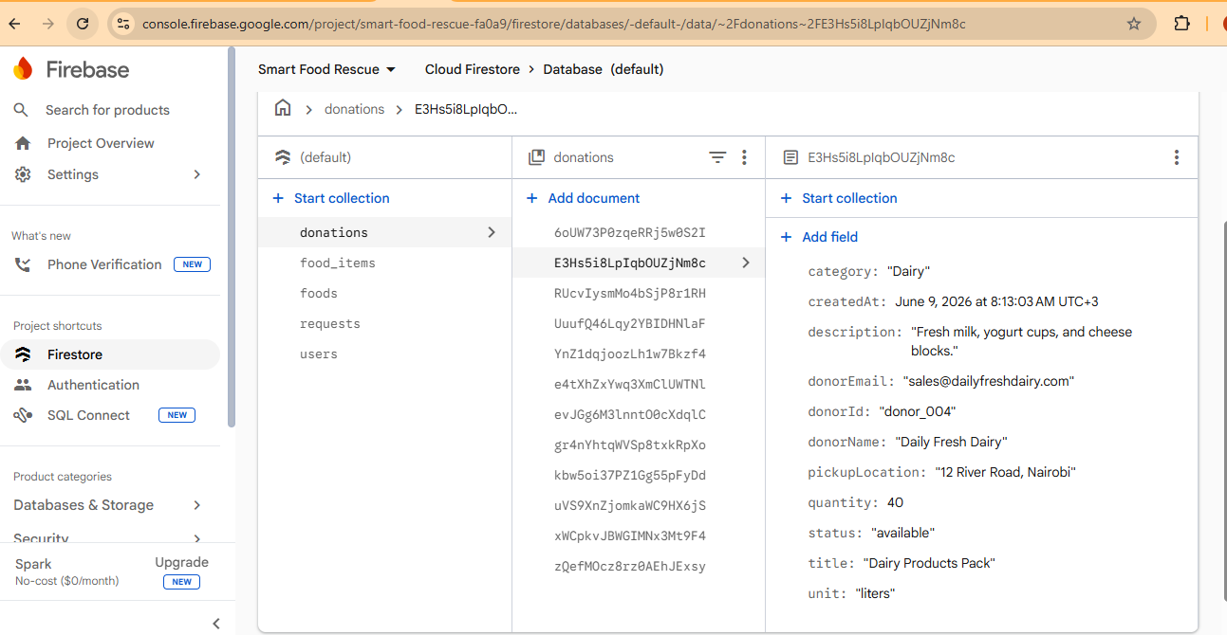

Main Food Donations List Screen

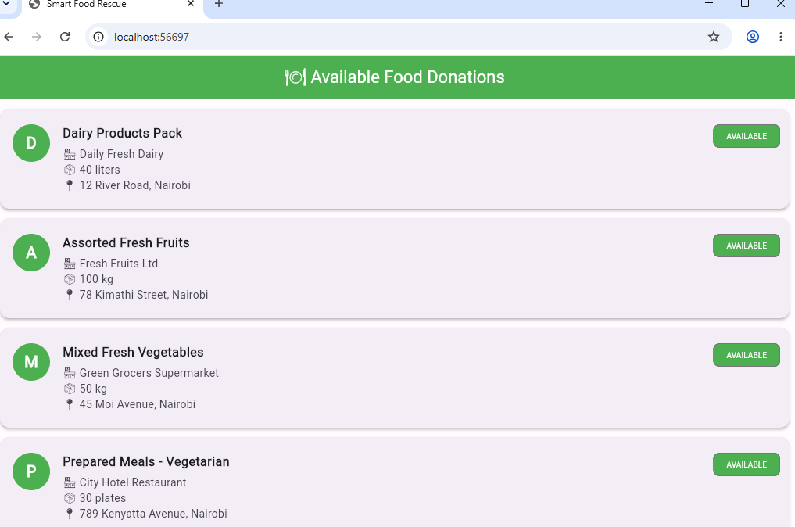
CLAIM FOOD SUCCESS MESSAGE
